**Recommended Thespian Point Awards**

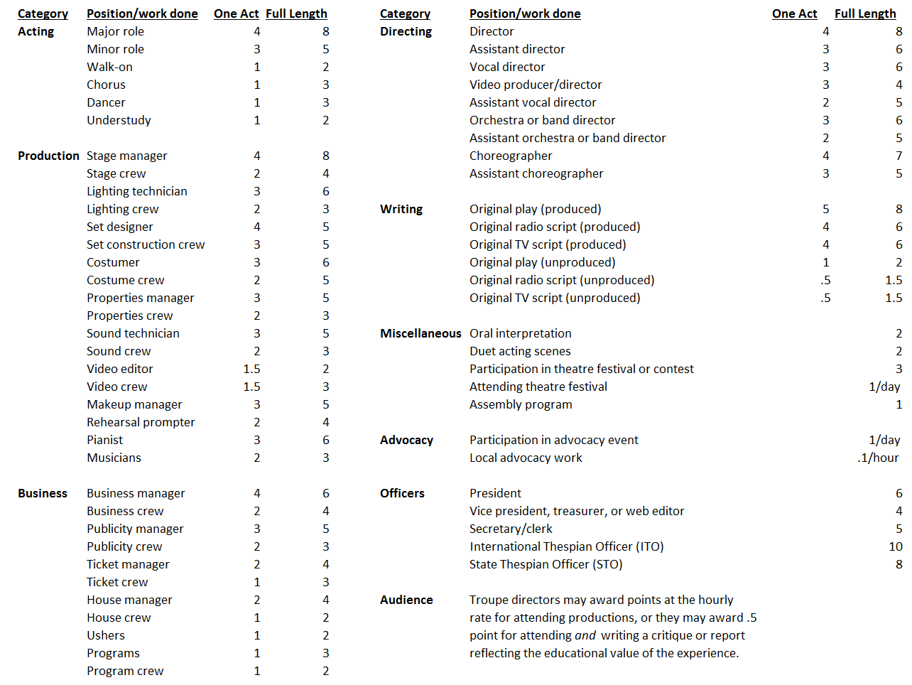

**Thespian Honor Rank Summary**

